Name:TH Kalpakam

Roll no:AM.EN.U4ECE22048

ASSIGNMENT-2

19ECE311 COMPUTER NETWORKS

Question:

Create 3 LAN networks connected via a single Router (CPT). Choose appropriate router, connection and configure it. Each LAN network is configured via Tree, Star and Ring topologies respectively.

The IP addresses  for the implementation of topologies should be chosen based on the 5 digits of  your Roll No.

Ex: U4ECE220XX      for A batch

      U4ECE221XX      for B batch

Ex IP address for Roll no 12 (for A and B batch) is:**220**.**12**.x.x for A batch and **221**.**12**.x.x for B batch. You may take the subsequent IP addresses based on the mentioned roll number IP.

Solution:

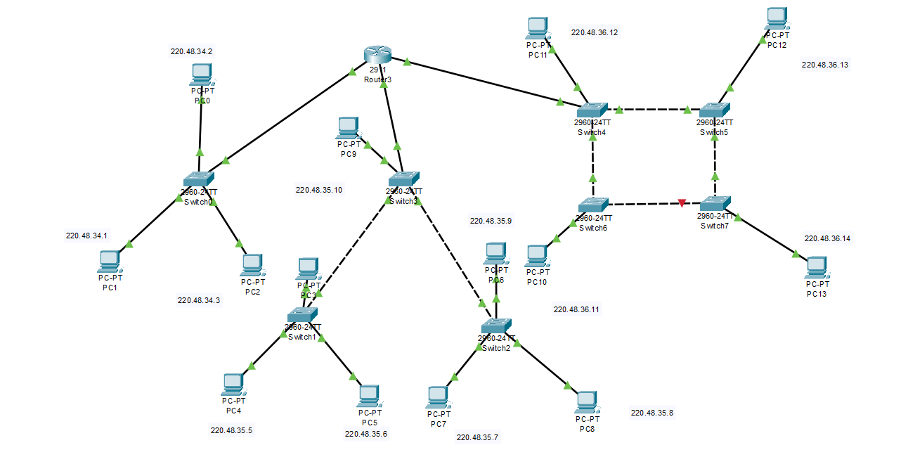

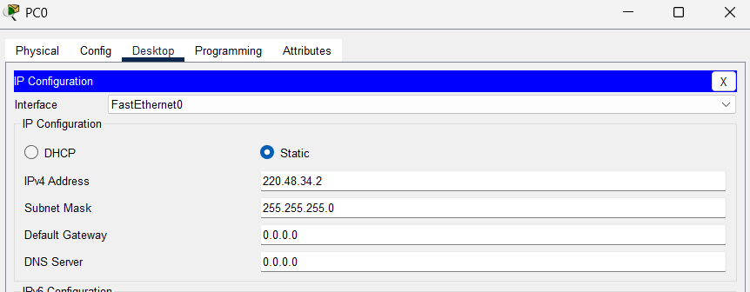

Pinging PC’s of different networks

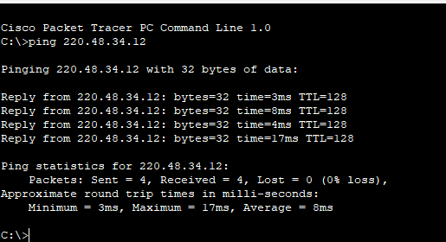

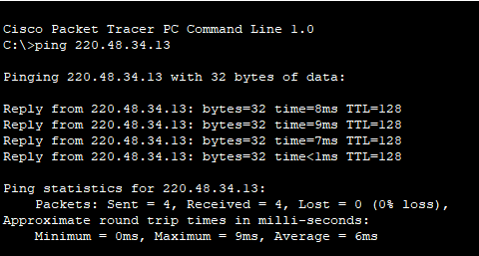

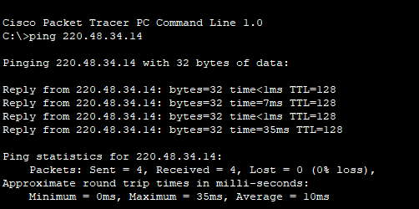

Router Configuration

